Waabanong Weekly Update
Week of April 28, 2026
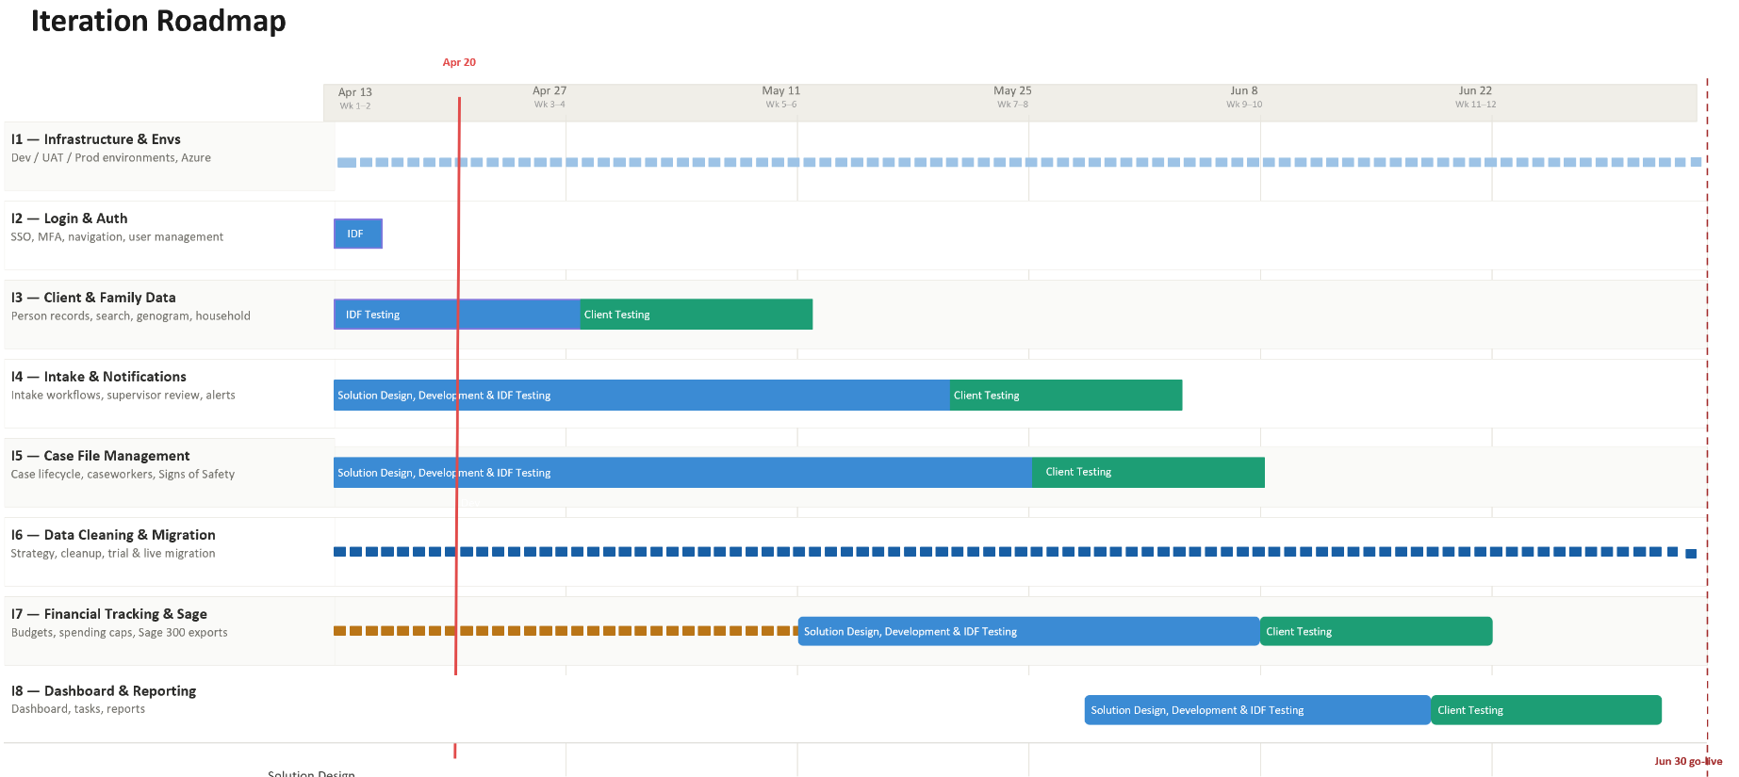

Iteration | Status | Current phase | Notes
I1 - System Infrastructure & Environments | In progress | Setting up Testing | Azure Testing environment data migration in progress
I2 - Login & Authorization | In progress | IDF Testing | Session timeout and logout management improvements deployed
I3 - Client, Member & Family Data | In progress | IDF Testing | Profile age checks and profile conversion logic merged; bug-fix cycles ongoing
I4 - Intake Management & Automated Notifications | In progress | In development | Major iteration shipped (PRs #26–#28); intake-to-case workflow refined per Ongoing Service walkthrough
I5 - Case File Management & Signs of Safety | In progress | Solution design | First wireframe walkthrough with PCFS Ongoing Service Team completed Apr 29; design updates queued
I6 - Data Migration | In progress | Planning | Working with Campfire to determine how to access data and maintain privacy/security
I7 - Financial Tracking & Exports for Sage | In progress | Discovery → Solution design | Finance design session Apr 28; advanced wireframes for PO and credit-card reconciliation in progress
I8 - My Dashboard & Reporting | Not started

Project Management & General
Weekly Progress
- Abuse Investigation module — two deep design sessions completed Apr 28; module workflow defined including intake handling, investigation lifecycle, evidence references, freeze on reporting, three-tier access management (regular / confidential / restricted), and request-closure workflow with auto-fill final report.
- Finance module working session Apr 28 — covered PO and credit-card reconciliation, role-based task assignment (finance assigner role), RBC export/import, audit/compliance, and global holiday calendar; recurring Tuesday finance working sessions confirmed.
- Ongoing Service Team — first wireframe walkthrough completed Apr 29 (two parts).
  - Covered intake-to-case handoff (cases first assigned to reconciliation directors, who then choose supervisor and worker), household / genogram, persons-in-case with address and in-home / out-of-home status, related cases, notifications vs. case history logging.
  - Confidentiality and safety — agreed to manage conflict-of-interest under safety/confidentiality using an inclusion-based access model (only assigned worker, supervisor, director).
  - Case attachments and mandatory checklists discussed (rename to “mandatory Child Services checklist”); financial face sheet implications for ending paid care and extended-family visits flagged for follow-up.
- Active development continued — session timeout/logout management, eligibility banner messaging, sticky intake header, Safari date picker fix, profile age checks and profile conversion logic; PRs #26 (intake-edit), #27 and #28 (bug-fix batches) merged to master.

I1 - System Infrastructure & Environments
Features
- Set up Development, Testing, and Production environments
Weekly Progress
- No new updates this period — Azure environment data migration continues in the background.
I2 - Login & Authorization
Features
- Microsoft 365–based authentication
- User login
Weekly Progress
- Session timeout improvements — improved local storage management, integrated debug logging, and proper logout on timeout.
I3 - Client, Member & Family Data
Features
- Centralized person records (children, adults, limited profiles)
  - Duplicate prevention
- Family and household structures
  - Multi-generation relationships
- Reciprocal relationship logic
- Global search across people and families
Weekly Progress
- Profile age checks and profile conversion logic merged.
- Continued internal testing and UI refinements (contact cards, address book, critical-information toggle).

I4 - Intake Management & Automated Notifications
Features
- Structured intake workflows with mandatory fields
- Intake status tracking and lifecycle
- Supervisor review and approval processes
- Ability to resolve intake without opening a case
- Escalation from intake to case creation
- Printable intake records
- Automated notifications:
  - In-application alerts
  - Defined external channels (email/messaging)
Weekly Progress
- Major iteration shipped — PRs #26 (intake-edit), #27 and #28 (bug-fix batches) merged to master.
- Intake-to-case workflow refined based on the Apr 29 Ongoing Service walkthrough — design updates queued to reflect first assignment to reconciliation directors and director-driven supervisor/worker selection.
- Eligibility banner messaging improved based on caregiver name and reason.
- Safari date-picker fix (Apr 30 / May 1); tooltip additions on sticky header; submit-button error-state fix on update intake.
- Sticky intake header refinements, timezone updates, and modal fixes.
- Address book toggle tooltip fix; Critical Information toggle issue fix; phone-number mask prefill fix on edit.
I5 - Case File Management & Signs of Safety
Features
- Case file creation and lifecycle management
- Assignment of caseworkers and supervisors
- Case reassignment with approval
- Signs of Safety–aligned workflows, including:
  - Placement
  - Structured assessments
  - Safety goals and planning
  - Ongoing review checkpoints
- Visibility into historical and related cases
- Case notes for visits, services, and interactions
- Communication tracking across intake and case contexts
  - Document management: Person, Intake & Case
Weekly Progress
- First wireframe walkthrough with the PCFS Ongoing Service Team completed Apr 29 (two parts).
- Design updates queued from the walkthrough.
  - Director field on case record; admin screen for team configuration (Director → Supervisors → Workers).
  - Persons-in-case list to show address and in-home / out-of-home status plus links to any open related case files.
  - Conflict-of-interest access — move into safety/confidentiality using inclusion-based access.
  - Role-based dashboards aggregating tasks across cases and intakes, sorted by priority and due date.
  - CEPA-related case-change/completion handling to be clarified and documented.
- Wireframes & Solution Design are in progress
- Preliminary wireframes covering case record type, case notes, and placement require review with Ongoing Service Team. Marcus to reach out to Ross to schedule.
I6 - Data Cleaning and Migration
Features
- Develop a data migration strategy from FAMCare into Waabanong
- Support PCFS as they perform data cleanup
- Execute trial data migrations in a sandbox environment
- Perform live data migration
Weekly Progress
- No new updates this period — anonymization approach still being scoped.
I7 - Financial Tracking & Exports for Sage
Features (Potential scope may include)
- Intake-level emergency supports
- Case-level budgets
- Spending caps and approvals
- Export files to import into Sage 300
Weekly Progress
- Finance design session held Apr 28 with the PCFS finance team.
  - Defined dashboard with pending actions, supervisor approvals, and final finance approvals.
  - Credit-card transaction reconciliation flow including RBC export/import and receipt attachment.
  - Role-based task assignment using a new “finance assigner” role; global holiday calendar to drive business-hour timers and holiday coverage routing.
  - Audit and compliance — Wabana to store full transaction detail (receipts, approvals) for audit.
- Recurring Tuesday finance working sessions confirmed; next session to review advanced wireframes for PO and credit-card reconciliation.
I8 - My Dashboard & Reporting
Features (Potential scope may include)
- My Dashboard (simple, quick reference to key items)
- Tasks & alerts
- Reporting (if required and not covered in other iterations)
Weekly Progress
- Future iteration per schedule (nothing this week).

